Use-Case Realization Report (Requirements)
Browse Project

Issue 1.0
Revision History
Date | Issue | Description | Author

Table of Contents
1. Brief Description 4
2. Flow of Events 4
2.1 Standard Flow 4
2.1.1 Browse Project 4
2.1.2 Raise Interest 4
2.1.3 Post User Stories 4
2.2 Exceptions 4
3. Interaction Diagrams 5
3.1 Domain Collaboration Diagram: Browse Project 5
4. Participating Objects 5
5. Derived Requirements 5

Use-Case Realization Report
Browse Project

Brief Description
The use case describes the project browsing of the system.

Flow of Events
The standard flow of events for this use case and any exceptions are described in the following subsections. See section 3.1 for an overview of the participating Actors and Domain Objects.

Standard Flow
Precondition: User already logged in the system

2.1.1 Browse Project
This use case provides the user interface related functionality that will be provided to the User, as follows:
- After user login, the system will be automatically redirected to ProjectMainScreen.
- The following information will be displayed on the ProjectMainScreen:
- All the projects that the user joined
- All the projects that user is currently joining
- All the active projects which has enough team members and which is currently progress
- All the active projects which has insufficient team members
- When user click a specific project, the system will display the project details, including:
- Project Name
- Project initiator
- Project Start Date
- Project Status
- Project Member List
- Project Interest List
- User Stories
- Project Calendar(if have)
- Project Itinerary

2.1.2 Raise Interest
Precondition: Use case 2.1.1 has been performed
This use case provides the user interface related functionality that will be provided to the User, as follows:
- User click ‘Raise Interest’ on the ProjectDetailsScreen
- The system will check if the user is qualified to be added to the interest list
- After checking, User will be added to Project Interest List
- The ProjectDetailsScreen will get refreshed

Post User Stories
Precondition: Use case 2.1.1 has been performed

- User click ‘Post New Story‘ link on the ProjectDetailsScreen
- The system will be redirected to UserStoryScreen
- User may enter text or attach pictures on the screen
- When user clicks ‘Submit’, the new user story will be appended to the existing user stories of the project

Post Project Feedback
- User click ‘Post Project Feedback‘ link on the ProjectDetailsScreen
- The system will be redirected to ProjectFeedbackScreen
- User can edit comments on the Screen
- When user clicks ‘Submit’, the new feedback will be appended to the existing feedback of the project

Exceptions
The following exceptions have been identified:

Interaction Diagrams

Domain Collaboration Diagram: Browse Project
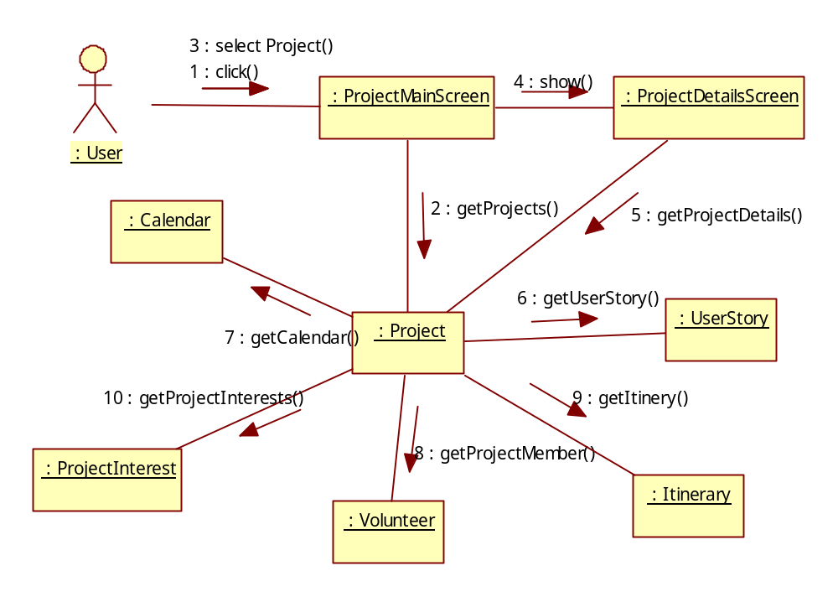

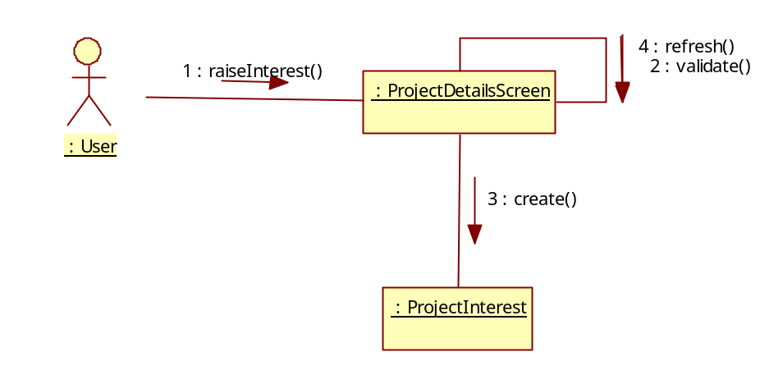

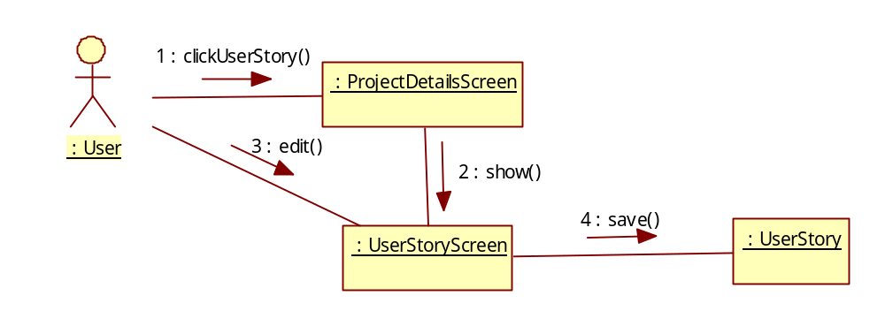
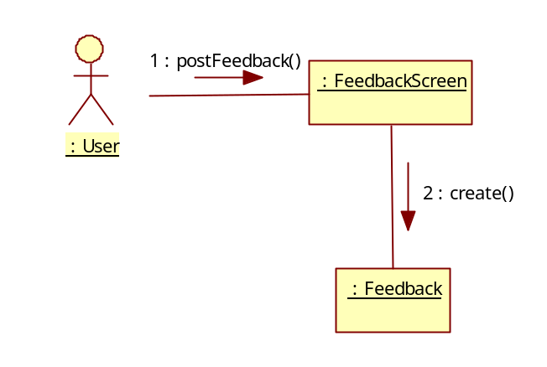

Participating Objects
:

Derived Requirements

